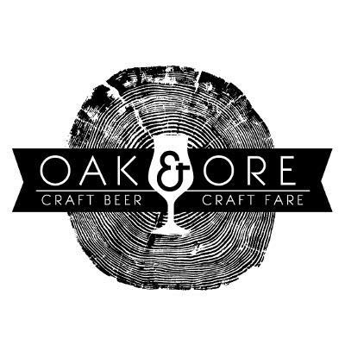

FOR IMMEDIATE RELEASE

Contact: Micah Andrews
Owner, Oak & Ore
405.312.2852
oakandore@gmail.com

Oak & Ore celebrates OKC Craft Beer Week with
Special Tap Events & New Brunch Menu

OKLAHOMA CITY (June 2, 2016) – OKC Craft Beer Week will take place June 12-19, and one of OKC’s most diverse craft beer bars will be celebrating every day. The Plaza District’s Oak & Ore will kick off the week with a special beer brunch on Sunday, June 12th, featuring three variations of Prairie Artisan Ales’ “Okie” brew, and finish the week with a Father’s Day Brunch on Sunday, the 19th, featuring new menu items and free bacon for dads.

Oak & Ore will hold a total of 6 beer events during OKC Craft Beer Week, highlighting breweries from all over the state, and including a benefit night on Thursday for the Craft Brewers Association of Oklahoma, which has been instrumental in new legislation for alcohol law reform.

“Oklahoma is home to some truly unique and innovative brewers. Some of them are well-known and respected internationally, and some are new to the scene and just being discovered.” said Oak & Ore owner Micah Andrews. “Recent legislation has finally put the state on a path that will allow local brewers to grow without unreasonable restrictions, and they can start reaching their full potential. We’ve always been proud to support the craft beer community, and OKC Craft Beer Week gives us another opportunity to continue a conversation we started back in January at the Oklahoma Craft Beer Summit.”

In addition to their focus on well-made beer, Andrews and Chef Eric Adams are also focused on serving high-quality food. Adams recently updated the daily menu with recipes he’s been perfecting over the last couple of months, and will unveil new items for the Sunday Brunch crowd at a Father’s Day Beer Brunch on June 19th.

“For our food menu, we take inspiration from the great beer that we serve. Some of these new recipes are a direct result of looking for flavors that would complement beers that I’ve really enjoyed,” said Chef Adams. “We’ve got some pretty exciting updates to our brunch menu that we’re pumped to launch at the week’s final event: Father’s Day Beer Brunch. What better way to celebrate Father’s Day than with beer, bacon, and breakfast for Dad?”

Oak & Ore OKC Craft Beer Week Schedule

June 12th, 11am – Prairie Beer Brunch featuring 2015 Okie, Coffee Okie, Pirate Okie and
Limited Edition glass mugs plus Prairie Beermosa specials until 2pm!

June 13th 6pm – COOP Barrel Aged Night: COOP Ale Works has made some awesome moves
in the barrel-aged game, and we’ll feature 4 of their best tonight, plus their brand-new
Peach Berliner Weisse. Tickets for limited edition glassware starting at 5pm!

June 14th 6pm – College Town Night: Stillwater vs. Norman! Iron Monk vs. 405 Brewing Co!
We can’t choose between these fantastic breweries. We’ll leave this one to the fans!

June 15th 6pm – Elk Valley Le Ferme Night: Elk Valley’s La Ferme is an amazing example of
Farmhouse ales, and we’ll feature 4 versions of it tonight, including the incredible
Apricot Chardonnay Barrel-Aged variant!

June 16th 6pm – Tulsa vs OKC Beer Playoff: We’ll pit some of Tulsa’s best brews against
some of OKC’s best. Marshall, Anthem, Roughtail and Dead Armadillo will duke it out for 1st Place. Fill out a bracket, and may the best craft beer win! A portion of the proceeds from this event will go to benefit the Craft Brewers Association of Oklahoma.

June 17th & 18th - OK Craft Beer Festival: Long day at the Festival? Come hang out, relax, and
chat about what you’ve seen and tasted, and about the future of craft beer in Oklahoma.

June 19th 11a-2p – Founders Father’s Day Recovery Brunch – We’ll unveil our new brunch menu items, celebrate Father’s Day, and recover from a week of amazing local beer events. Along with free bacon for all the dads, we’ll feature three classic breakfast brews from Founders Brewing: Breakfast Stout, KBS, and Sumatra Mountain Brown.

About Oak & Ore
Founded in December 2014, Oak & Ore offers a rotating, 36-tap selection of brews from Oklahoma and around the world, thoughtfully paired with a craft beer-inspired dining experience. For more information visit www.oakandore.com.

Related Media
Oak & Ore photos

